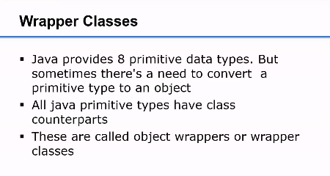

**Need of wrapper classes**

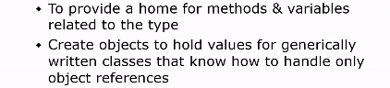

**List of wrapper classes in java**

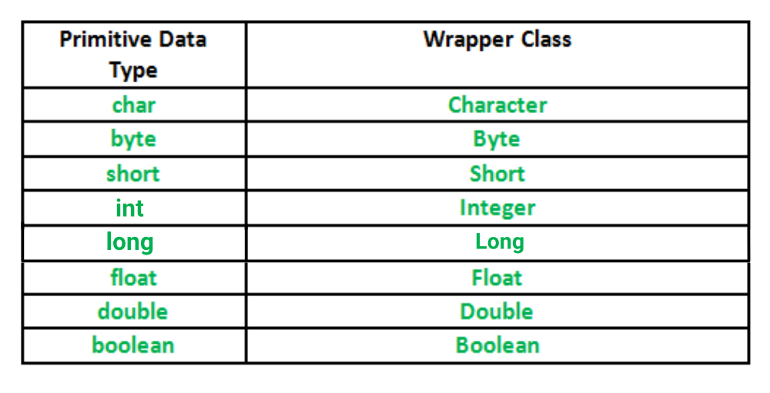

**Autoboxing**

Autoboxing is the automatic conversion that the **Java** compiler makes between the primitive types and their corresponding object wrapper classes. For example, converting an int to an Integer, a double to a Double, and so on.

**Unboxing**

Converting an object of a wrapper type (Integer) to its corresponding primitive (int) value is called **unboxing**.

**Characteristics Of Wrapper Classes**

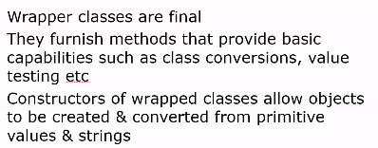

E.g. int intVal = 10;

int intObj = new Integer(intVal);